Both Falcon 1 and 1e share a second stage.

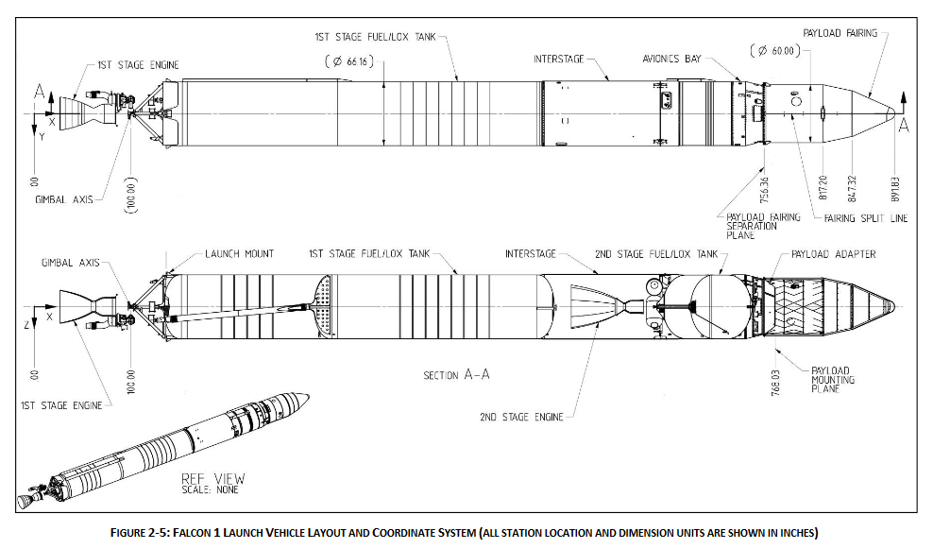

12.5ft

29.2ft

70ft

Total length of Flacon 1e - 90 ft rather than 70ft

First stage Length – 60.8ft – 18.5m with engine

Total mass – 92680lb - 42038.9kg

Mass of Merlin 1-c – 470kg

Scalable mass - 42038.9-470 = 41568.9kg

Scaled max mass of Falcon 1e at 9.5m

9.5/18.5\*41568.9 +470 = 21816kg

Nozzle – measured diameter – 2.75ft = 0.8382m

Area = 0.5518m^2